OFFICIAL COORDINATION REQUEST FOR NON-ROUTINE OPERATIONS AND MAINTENANCE

COORDINATION TITLE- 13 LWG 17 Lower Granite Juvenile Fish Collection Channel Upgrades
COORDINATION DATE- initially September 10, 2013; recoordinated November 14, 2013; recoordinated 15 December 2015; recoordinated 08 February 2016
PROJECT- Lower Granite
RESPONSE DATE –

Description of the problem
Construction activities associated with the Lower Granite fish bypass system upgrade will require extensive onsite efforts over an approximate 36 to 86 month construction schedule. While many of the construction activities can occur during normal project operations, some activities may require alteration of normal project operations. The time necessary for completion of construction activities will be directly correlated with the construction methods employed. The existing collection channel within the powerhouse will require extensive concrete mining to expand the channel from 6 ft. to 9.5 ft. and the replacement of eighteen 10” orifices with 14”orifices. The construction method for concrete mining has yet to be determined but the USACE is approximating 6-10 months to complete the task which likely translates into three un-watered work windows (15 December to 24 March). On the other end of the spectrum for construction schedules, a single un-watered work window of 1 August to 24 March is anticipated to allow for construction activities without interruption and benefit the collection mining process. All potentially anticipated construction scenarios have various pros and cons on project operations, fish passage, and overall project costs.

12/14/15 UPDATE: The construction contractor anticipates widening the juvenile collection channel at Turbine Units 5 and 6 during the 2015/16 unwatered work window (MOC: 15 LWG 023 Modification Early Shutdown of Lower Granite Juvenile Bypass System) and the remainder of the channel during the agreed to extended 1 August to 24 March JBS outage as described herein.

The USACE’s Fish Passage Plan (2013) calls for the collection channel to be operated from 25 March to 31 October for juvenile passage and collection and 1 November to 15 December for adult fallback passage. Spill operations typically begin 3 April and end 31 August. The proposed extended un-watered work window would alter the normal operations of the collection channel and as a result limit the available passage routes to the spillway and turbines during the month of August. Available passage route for September to December would be via the turbines. The Corps proposes that the RSW operate from 1 September to 15 December to allow alternate passage routes for juvenile and adult salmonids. The RSW would operate under the following scenario:

1. Operate the RSW 12 Daytime hours per day (6am to 6pm) from 1 September to 15 December.

Operating the RSW during the extended un-watered work window would require discharge through the RSW of 6.8 kcfs. During low to average river flow years, minimum generation requirements through the turbines may result in a lack of water to operate the RSW and maintain minimum operating pool. In that case, the RSW would need to be closed and flows would be routed through the turbines while maintain minimum operating pool levels. As a note, more than 6.8 kcfs may be discharged through the RSW during periods when Lower Granite Dam is operated outside MOP in accordance with the FPP.

14 December 2015 UPDATE: The Corps is requesting an extension to the 2016/17 in-water work window to facilitate construction of the new primary bypass outfall (MOC: 15 LWG 025 Lower Granite JBS Primary Outfall Construction). As discussed at the 7 December 2015 NWW FFDRWG meeting, it may be necessary to modify or curtail spill operations starting 15 November 2016 to allow safe construction operations to proceed in the LGR tailrace.

5 February 2016 Update: As described in MOC 15 LWG 025 LGR JBS Primary Outfall Construction, it may be necessary to deviate from the daytime (6 am to 6 pm) RSW operation described herein to facilitate construction of the new primary bypass outfall.

The Corps is exploring construction methodologies for installation of the 14” orifices to determine whether a caisson in front of the respective orifice can be used to facilitate construction instead of dewatering the turbine and respective gatewell with a bulkhead and deviating from FPP Table LWG-5 unit priorities. If it is necessary to deviate from unit priorities as described in FPP Table LWG-5, deviations will be limited to the November-December time period and will be further coordinated with FPOM prior to deviation.

Table 1. – Average inflows and turbine discharge at Lower Granite Dam, 2006 to 2012. Inflow and powerhouse discharge are reported as kcfs.

Month | Inflow (kcfs) | Powerhouse (kcfs)
August | 31.05 | 13.20
September | 24.77 | 23.95
October | 21.07 | 20.60
November | 21.73 | 20.70
December | 24.03 | 23.65

Table LWG-5. Lower Granite Dam Turbine Unit Operating Priority Order.
Season | Duration | Unit Priority
March 1 – December 15 Fish Passage Season | Start Units | 2, 3, then 4-6 any order, then 1 a
March 1 – December 15 Fish Passage Season | Stop Units b | 4-6 any order, then 3, 2, 1 b
December 16 – end of February Winter Maintenance Period | Stop/Start Units | Any Order
- Unit 1 has fixed Kaplan blades (non-adjustable) and can only operate in the upper 1% range. The priority order minimizes Unit 1 starts/stops and allows for the longest runtime once Unit 1 is started.
- Stop units in reverse Start order, except run Unit 1 as long as BPA load request and required spill rate can be met.

Type of outage required
The removal of ESBS’s and the closure of the collection channel from 1 August 2016 to 24 March 2017. Open the RSW for fish passage from 1 September to 15 December.

Impact on facility operation
The impact to facility is the early closure of the collection channel and the de-watering of the Juvenile Fish Facility in August 2016 instead of normal December closure.

Dates of impacts/repairs
1 August 2016 to 24 March 2017

Length of time for repairs
The construction of the Juvenile Bypass System is began in the fall of 2014 with completion in the spring of 2017. The extended un-watered work window is expected to occur from 1 August 2016 to 24 March 2017.

Expected impacts on fish passage
The closure of the collection channel may impact juvenile salmonids passage and transportation (Table 2) and adult fallbacks (Table 3) and require their passage through the spillway, RSW or turbines. Fish that are entrained in the gatewells will need to be dipped out and transported to the boat ramp for release downstream of the dam. After the initial dipping effort, project personnel will monitor the gatewells for signs of fish problems during the extended work window. This will require additional staff time for both JFF staff and Smolt Monitoring staff. It will not be possible to gatewell dip slots during this extended JBS outage as it is necessary to store ESBS’s in the upper portion of the gatewell slots during construction activities. The limited ESBS storage locations will be utilized to facilitate installation of 14” orifices.

Changes to Turbine Unit Priorities during the November-December timeframe may impact upstream adult steelhead passage and adult chinook to a limited extent (Table 4, Table 5). If necessary to deviate from typical unit priorities while installing orifices in units 2 and 3, the Corps will keep the respective adjacent unit available for service (e.g., unit 3 will be available while unit 2 is taken offline). RSW spill or 6.8k cfs (4 stops) during daytime hours (6 am to 6 pm) will be maintained during this time period if possible as described herein and in MOC 15 LWG 025 LGR JBS Primary Outfall Construction.

Table 2. – Juvenile salmonid collection and transportation at Lower Granite Dam Juvenile Fish Facility, 2006 to 2012. Data collected by USACE.

 |  | Collected |  |  | Trucked |  |  | Barged
Year | Aug | Sept | Oct | Aug | Sept | Oct | Aug | Sept | Oct

2006 | 1,841 | 2,107 | 4,219 | 613 | 2,071 | 4,067 | 1,425 | 0 | 0
2007 | 2,056 | 1,124 | 10,407 | 553 | 721 | 6,281 | 1,432 | 0 | 0
2008 | 21,047 | 9,220 | 8,731 | 6,032 | 4,560 | 6,007 | 16,033 | 0 | 0
2009 | 3,044 | 2,002 | 2,115 | 1,012 | 1,246 | 1,334 | 1,957 | 0 | 0
2010 | 8,907 | 8,436 | 11,436 | 3,071 | 5,523 | 8,000 | 5,637 | 0 | 0
2011 | 6,498 | 14,307 | 5,721 | 1,692 | 10,577 | 3,206 | 6,330 | 0 | 0
2012 | 8,121 | 6,443 | 12,255 | 2,040 | 3,774 | 9,068 | 5,875 | 0 | 0

Adult fish passage under low tailrace flow conditions will need to be monitored for any delay associated with adverse tailrace conditions. If necessary, unit operation or spill distribution and timing will be adaptively managed as appropriate, within the constraints of water availability, to improve adult fish passage conditions. RSW operation is expected to aid fish falling back with a safe passage route.

Table 3. – Adult salmonid fallback at Lower Granite Dam, 2006 to 2012. Data collected by USACE personnel as adult salmonids cross the JFF separator.

Year | August | September | October
2006 | 51 | 335 | 630
2007 | 67 | 270 | 846
2008 | 275 | 798 | 2,253
2009 | 247 | 3,462 | 2,940
2010 | 477 | 1,202 | 1,919
2011 | 179 | 1,547 | 2,787
2012 | 81 | 752 | 2,090

Table 4 – Lower Granite Dam Chinook Adult Passage Counts (October – November)

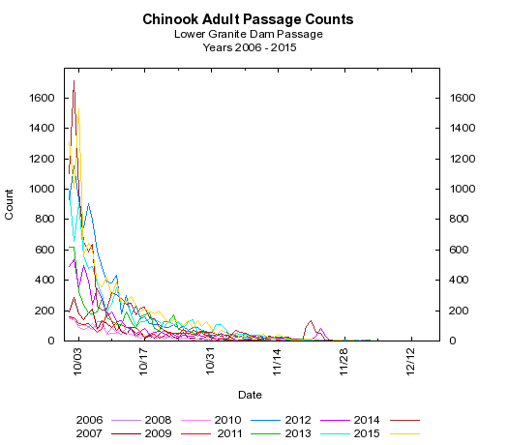

Table 5 – Lower Granite Dam Steelhead Passage Counts (October –November)

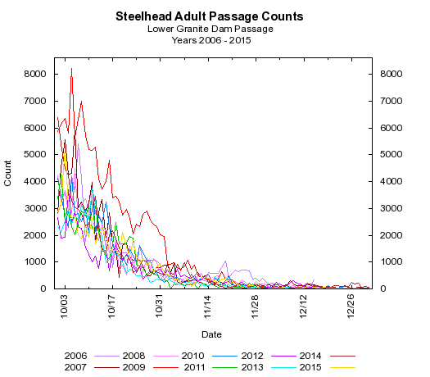

Comments from agencies Final results
-----Original Message-----
From: Bill Hevlin - NOAA Federal [mailto:bill.hevlin@noaa.gov] Sent: Wednesday, November 13, 2013 10:22 AM
To: Mackey, Tammy M NWP; Fielding, Scott D NWW
Cc: Ritchie Graves - NOAA Federal; Bill Hevlin - NOAA Federal
Subject: [EXTERNAL] Re: FW: Updated MOC for LGR extended unwatered work window (UNCLASSIFIED)

Tammy and Scott,

Thank you for coordinating with NOAA Fisheries on the construction and in-water work schedule for the Lower Granite juvenile bypass collection channel improvements, which are recommended in the NMFS FCRPS Biological Opinion. NOAA supports the Corps' proposal to de-water and close the powerhouse juvenile collection channel from August 1, 2015 to March 24, 2016. We understand that this one long closure of the collection channel will allow completion, thereby avoiding two collection season operations with a partially completed channel - which would entail a higher risk to fish passage - and three winter in water work windows, increasing the cost of the project. NOAA supports the Corps' proposal for alternative fish passage routes during the collection channel shut down. We understand that during the initial closure period, August 1 - 31, 2015, the Corps will maintain the usual 18 kcfs summer spill volume for juvenile passage and adult fallback, unless there is not enough river flow to provide minimal powerhouse operation and avoid adult passage problems. During the September 1 to December 15, 2015, outage period, the Corps will operate the RSW, 6.8 kcfs, daily, 6 am to 6 pm for fish passage, as long as minimal powerhouse operation can be maintained and no problems are noted with adult passage.

NOAA Fisheries requests that these alternative operations be entered in the Fish Passage Plan once FPOM has reached agreement. If you have any questions in regard to NOAA's comments on this coordination please feel free to contact me.

Bill Hevlin NOAA Fisheries

Discussed at November 14 FPOM meeting and approved by participants.

David Trachtenbarg
Fish Biologist
Environmental Analysis Section
U.S. Army Corps of Engineers
Walla Walla District
201 N 3rd Ave.
Walla Walla, WA 99362
Phone: 509-527-7238

